(Austin) Drew Rottermond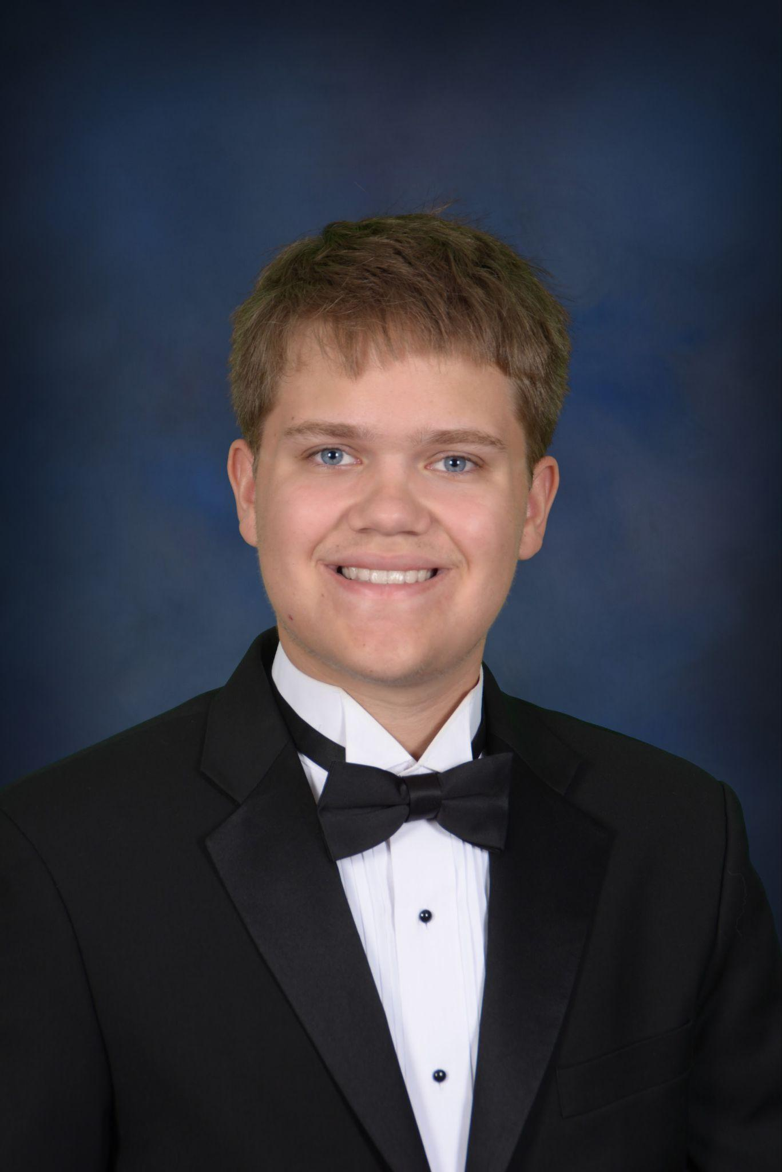

[austin.rottermond@gmail.com](mailto:austin.rottermond@gmail.com)

12th grade

Planning on going to UTD (Accepted)

I worked on the weapon systems and core functions for the player character, as well as fundamental functions for enemies (Death handling, scrap). I also worked on VFX for weapons and their explosions, and making them useful in-game.